INTRODUCTION

Demolition can be defined as part of construction on site, which involved, upgrading the existing structures, renovation works and refurbishment and sometimes involving an alteration works where usually contributed small proportion in construction work, can be divided by two types, partially and fully.

Before any demolition can be done, a detailed survey of the property should be made. Photographs should be taken of the works to be demolished, together with any adjoining property. The photograph will serve as valuable evidence in the event of claims being made against the contractor. A check must be made of any legal rights which may affect the demolition, including easements and questions of ownership, as well as liability for damage and trespass.

Detailed surveys of the buildings to be demolished should include the followings:-

- Framed building– will unbalanced thrusts occur when members are removed?
- Walls– load bearing or non- load bearing: stability of party walls if floor and roof removed.
- Support required for all elements where stability is to be reduced.
- Any cantilevered structure– nature of support
- Basement and voids– methods of filling or protecting
- Underground storage tanks– position, size, contents and tanks
- Supplies and services. These may include :
  - Drainage, gas, electricity, water, telephone, television or radio line, hydraulic pressure mains, district heating mains.
  - Benchmark on buildings– which involve informing the Ordinance Survey Office.

Work On Site for Demolition

The demolition contractor is required to appoint a competent foreman to supervise the work and a program of propose sequence of operation should be prepared. Particular attention should be given to the following:

- Licenses for hoarding, fencing, lighting etc.
- Scaffolding for access purpose.
- Closing of road– special notice to local authorities.
- Access to site– may need special protection, planning permission will be required if access leads directly on to a highway
- Services– may required specialist treatment, diversion
- Health and safety– workmen must be protected at all times
- Uncontrolled collapse– uncertain method of support shoring etc.

1.O DEMOLITION PROCEDURES

1.1 Preliminary Procedure

Demolition and alteration operations are the subject of strict legal controls. There is a substantial body of legislation and a great deal of case law relating to such operations. There may also be some regulations, which impose additional restrictions: for example, action against nuisance such as noise and dust. The BSI Code of Practice for Demolition BS 6187 exerts further influence, in that if the demolition contractor does not observe the recommendation of the Code, this may well influence a Court's decision as to his liability in any legal proceedings.
Demolition is a highly skilled and dangerous activity in terms of damage to life and property. There are certain basic factors to consider before a contract is placed:
- The demolition contractor should have ample experience of the type of work to be offered;
- Fully comprehensive insurance against all risks must be maintained at all times;
- An experienced supervisor should be continuously in charge of the work;
- The contract price should include all safety precautions included in the relevant building regulations;
- The completion date should be realistic, avoiding and need to take risks to achieve the date.

1.1.1 Pre-Demolition Checks (Site Inspection)

General

Check the site, building or structure and its contents for likely hazards. These may include asbestos, electric power lines cables, gas reticulation, telecommunication, and unsafe structural members. Pedestrian and vehicle movements passing the site must be determined and traffic control facilities protected.

Adjoining Buildings

Check the relationship and the condition of the adjoining buildings. They could be affected by the demolition. For instance, they might rely for support on the building to be demolished, be very susceptible to damage by ground shock, or have shallow foundation or contain poorly stacked or fragile materials. Find out if they are any restriction concerning right of support to adjacent buildings.

Use of the Building

Find out what the building was used for in the past. They may be dangers from explosive or flammable substances, toxic substances, lead, asbestos and radioactive substances. Asbestos must be removed prior to demolition. Check with the Territorial Authority to determine a dangerous goods license has ever been issued for underground tanks.

Dangerous structures

If a structure seems dangerous, check with the territorial Authority. They may know about the type of construction and the cause of the damage or weakness. Find out if the Territorial Authority has a site with notes on special features.
Public services

All services, either underground or above ground, such as gas, water, electricity, drains, telephone cables, etc, must be relocated. Arrangements must be made to have them either cut off or diverted at the site boundary, or suitability protected to the approval of the appropriate authority. In some cases, more than one source of supply may be found. Particular care needs to be taken out when constructing boundary fences or gentries, to ensure their foundations do not strike public utilities that are still in use. Provision must be made for the safety of pedestrians and vehicles passing the site. Footpaths must be maintained in the safe condition.

1.1.2 Pre- Demolition Checks (Structural Inspection)

Building Plans

Examine all available plans of the buildings where necessary, but be aware that the original drawings may not be a true record of what was actually built. Where the nature of the construction is uncertain, a special investigation must be carried out. Seek the advice of a registered engineer. Where it is intended to use heavy plan in machinery on roof and floors, the allowable loadings must be determined. Propping or strengthening may be necessary. “No go” areas for plant and machinery should be fenced off to avoid confusion as to what is safe and what is not.

Roof

Examine the roof structure. Check the condition of roof trusses and identify and mark any bracing that is essential for its stability. Check the nature and condition of roof cladding. If it brittle, special precautions must be taken to prevent the employees from falling through it. In particular, care must be taken corrugated “plastic” and asbestos cement roofing.

Walls

Examine the walls. Identify and mark load-bearing walls and check whether party or cross walls are properly bonded into front and rear walls. Check the thickness and condition has been completed. Note particularly any reduction in wall thickness. Any effect on remaining buildings due to removal of buttressing walls must also be considered. If in doubt, consult a registered engineer.

Cantilevered Structures

Check the cantilevered structures such as staircases, balconies, and cornices etc, which are fixed to a building. Their stability is likely to be effected when adjoining structural members in the building are removed. For instance, if a cantilever is the continuation of the building’s roof or floor beams it may collapse when the beams inside the building are cut.

Concrete Structures

These should be examined the signs of damage due to the corrosion of reinforcement or damage to the concrete. Additions and alterations may required special consideration.

1.1.3 Safety Precautions during Demolition

Demolition work creates high potential for risks to workers and the general public. Great care is essential and following the information in this leaflet will reduce the risk of serious outcomes, ranging from lost time, to serious injuries and death.

Before the start of every demolition job, the demolition contractor should take a number of steps to safeguard the health and safety of workers at the job site. These preparatory operations involve the overall planning of the demolition job, including the methods to be used to bring the structure down, the equipment necessary to do the job, and the measures to be taken to perform the work safely. Planning for a demolition job is as important as actually doing the work. Therefore all planning work should be performed by a competent person experienced in all phases of the demolition work to be performed.

General

Accidents have been caused during demolition by:

- Person falling from high, unprotected workplaces and though openings
- Person being struck by falling objects
- The building collapsing suddenly and unexpectedly
- Insecure materials in or on the structure
- Plant being used on elevated slabs without proper precautions being considered.

Safety precautions must be taken to safeguards persons working on the site and members of the public who are in the vicinity, as well as do protect property likely to be effected by the demolition.

Supervision

The contractor will ensure that the competent person is in constant charge of the demolition while it is being carried out.

Personal Protective Equipment (PPE)

Safety equipment protects only if it is being used in accordance with the supplier’s instructions. A number of hazards in demolition work required the use of personal protective equipment. These hazards range from the sharp edges on debris to exposure to hazardous chemicals.
Employers must ensure that employees are provided with, and use, protective clothing and equipment, goggles, face shields, hearing protective devices, safety belts, gloves and appropriates respirators for dust or chemicals must be provided as necessary.

1.1.4 Material

All materials arising out of the demolition and alteration work shall become a property of the Contractor who shall allow credit for the full value to him off all material salvaged. The Government shall be entitled to purchase salvaged materials from the Contractor upon payment to the Contractor of the credit value.

1.1.5 Workmanship

Demolitions are to be carried out in such manner and sequence as to cause the least impossible disturbance to those parts of the works, which are to remain.

1.1.6 Protection

The Contractor will responsible for the full protection of those parts of the buildings which are to remain including the provision of temporary dust- proof screen, tarpaulins, dust sheet and the like.

1.1.7 Dimensions

Dimensions of the building and other structures to be demolished, where given in the description of works, are approximately and are for guidance only.

As general, the demolition and alteration contractor must fulfil the entire requirement for general site provisions above:

Plant and Equipment
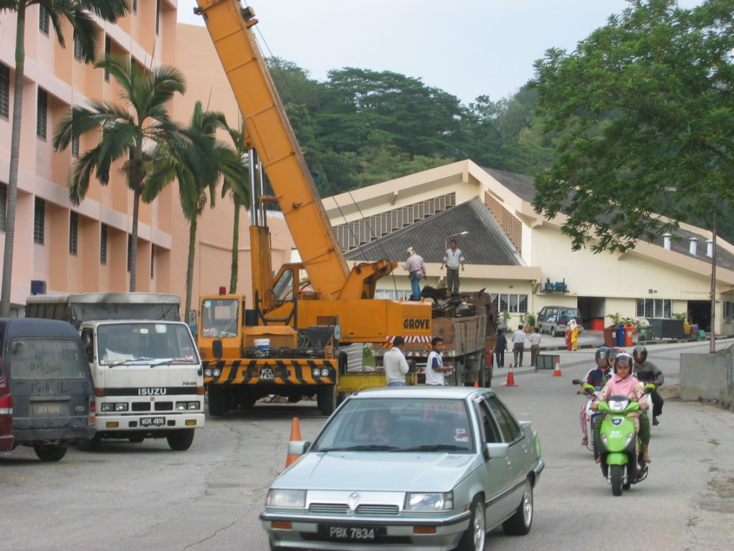

Mobile Crane
Must only be operated by skilled operators and must be regularly serviced.

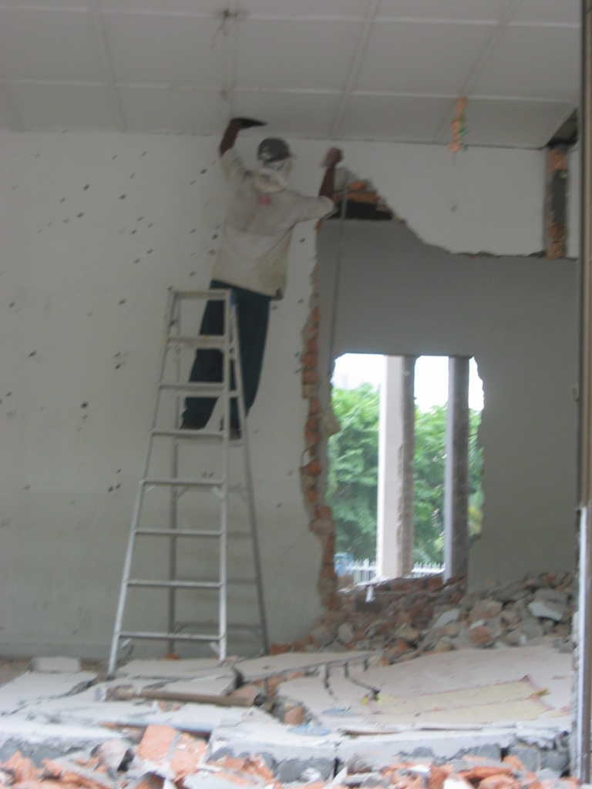
Protective Clothing

A worker with protective clothing

Buildings where chemicals have been stored or where asbestos, lead paint, dust or fumes may be present will require specialized protective clothing, e.g. respirators, helmets, goggles, footwear, gloves, etc. Projecting nails, pieces of metal, etc. resulting from demolition can cause accidents.
- Shoring and Underpinning
The demolition contractor has a legal obligation to show technical competence when carrying out the work. When removing sections of the building which could have leave other parts unsafe, adequate temporary supports and shoring etc. must be provided.

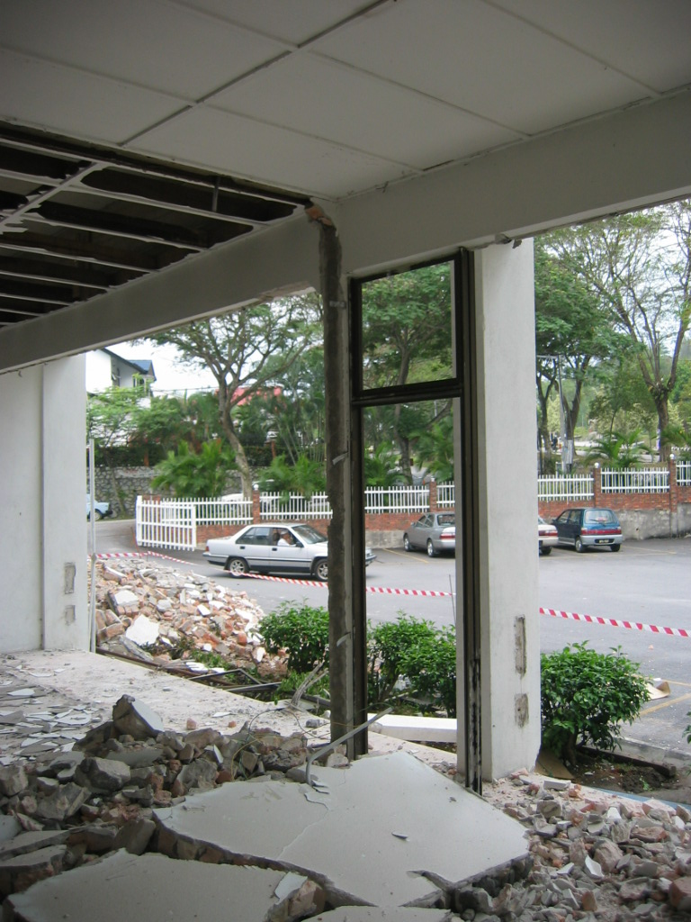
Working Areas

Safety tape (Red Color)
These will need to be well signposted and clear warnings given that demolition work is in progress. This may include the necessity for some kind of tape indicating dangerous work on progress.

Debris
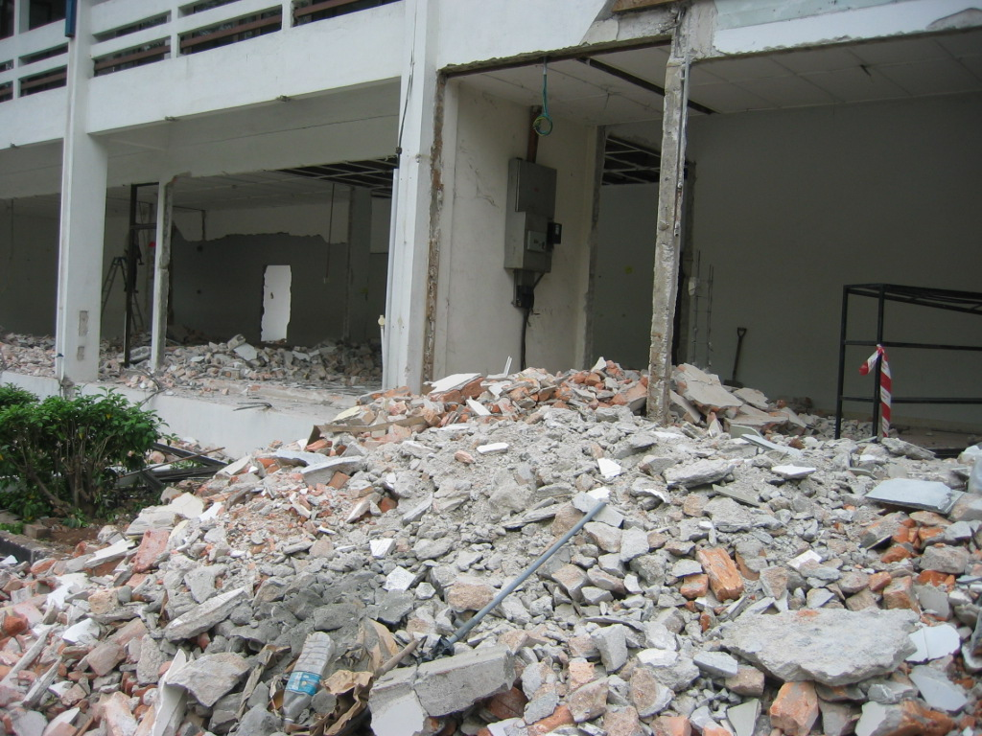

A bulk of debris ready to be removed

Sections of the building must not be overloaded with debris either on suspended floors or against party walls. Where practicable, demolished material should be lowered to the ground and the debris sent down in skips or enclosed chutes. Material should only be dropped when adequate precautions have been taken for safety of employees, public and adjacent property. When loading trucks or trailers, care must be taken not to spill debris over the far side of the truck or trailer. Loading shall be done on the demolition site unless permission been given by Territorial Authority to load on the street.

Weather Conditions
These can affect safety. Strong winds against unsafe walls, suspended floors etc. which are improper may lead to collapse.

Flooding
The build-up of water can sometimes be hazardous.

Overhead Cables and the likes
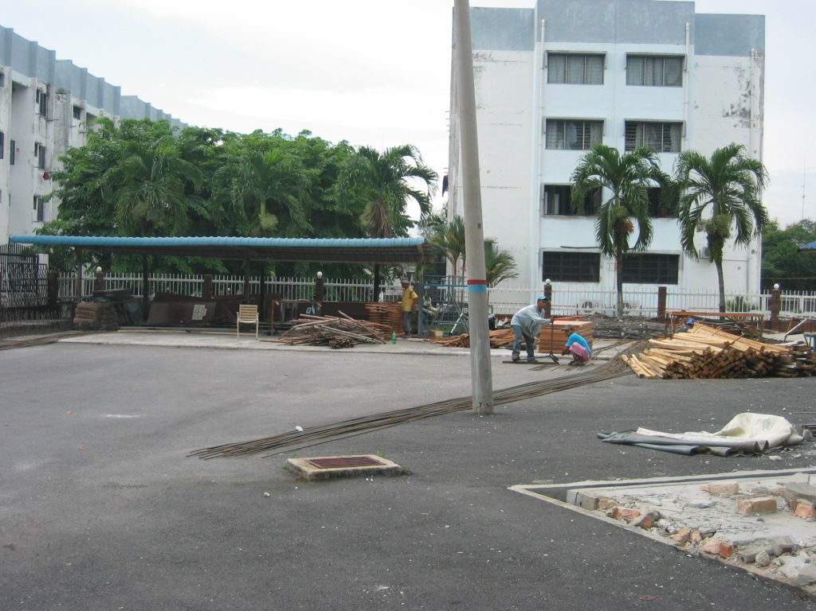

TNB light post
A crane heights etc. must be checked against the height of any surrounding overhead cables to avoid damage and cutting off supplies etc.

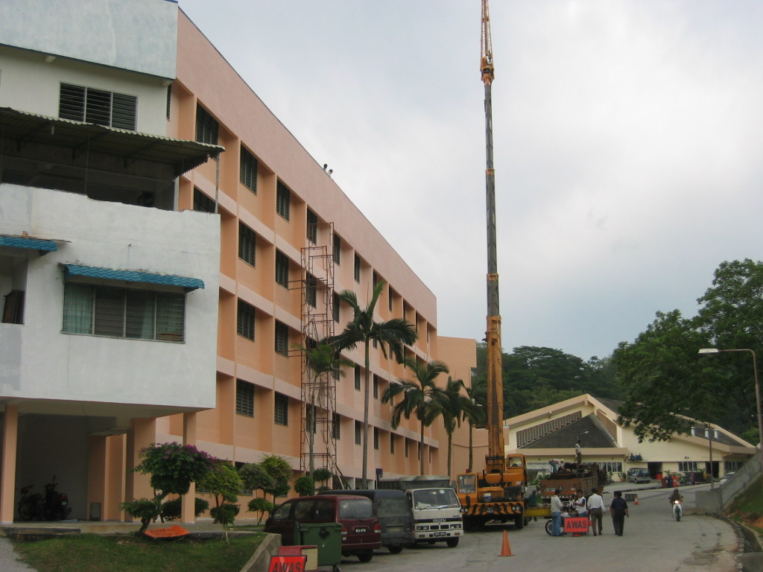
Scaffolding and Hoarding

Scaffolding equipment can bee seen

These must be constructed and illuminated to the relevant building regulations. All temporary works and protective structures, including hoardings, gantries, screen, and scaffolds and propping should be erected before demolition begins, and maintained in good order throughout the duration of the work. Demolition must be carried out in planned sequence. Ensure that everybody is kept at a safe distance, and that no one enters the building once demolition by deliberate collapse has begun.

Security
The demolition site and any partially demolished buildings must be properly secured against entry.

Dust
Demolition works often creates large volumes of dust, which, in windy, busy or densely populated areas, can be dangerous to the public. Should be kept to a minimum by spraying with water when necessary, watering down of debris, including loaded of vehicles, chutes, floors, stairways, and other places, must therefore be carried out frequently.

Noise
Suppressors and silencers, particularly on compressors etc., should be used to keep noise levels to a minimum. The contractor will ensure that necessary precaution are taken to protect their employees, the general public and occupiers of adjoining property from harmful noise. The best practicable means should be adopted to ensure that noise emission does not exceed reasonable levels.

Fire Prevention
Welding and cutting operations present a severe fire hazard on a demolition site. When practicable, combustible material in the vicinity of welding or cutting work shall be removed to a safe place. The use of flammable gases and oxygen poses additional fire hazards. Pure oxygen is extremely dangerous; it can set fire to oil or grease by spontaneously combustion without a flame of spark.

Building
To prevent injury from broken glass, all glass must be removed from windows before demolition begins. Window opening on street frontages, or adjacent to access ways, must be blocked off.

Opening in walls, floors and stairways, through which people could fall, must be boarded up or be provided with the guardrail and toe board, or both. Access to the areas flooring has been removed must be barricaded off, and notices erected to warn of he danger at each point entry.

All stairs or installed ladder must be checked before use. Never assume they are sound; it may have years since they were used. When in good condition, leave them as a mean of access or egress for as long as possible.

When dismantling pitches roof trusses, the last frame should be guyed before the second last truss is removed, because its stability depends on the support from adjacent members. As support from buttresses is removed, bracing should be provided to stabilize the remaining structure

Avoid free- standing walls by reducing the building in small lifts. Never leave isolated walls or potentially unstable structure or potentially unstable structure unpropped, unless they are stable against the wind and other forces likely to affect them.

When demolishing a reinforced concrete floor, it may be necessary to remove a small section first in order to determine the direction of the main steel.

Provide support from beams before cutting them free of columns and walls, if necessary. Column must be guyed before cutting or weakening the base, so that their fall may be controlled. Clear opening should be made in floors to allow debris pass through.

1.1.8 Safety Checklist

Before Works Starts:

- Has the building been inspected by competent persons and checked for areas containing asbestos, lead coatings and other toxic substances?
- Have all public services, such as gas, water, electricity, sewers and telephone been located? Have the authorities concerned been notified and have diversions been arranged as necessary?
- Has a demolition plan or method statement been prepared?
- Has the load bearing capacity of floors to be used as working platforms been checked?
- Have the necessary props, scaffold, fencing, protective screens, lighting, danger notices, fire protection equipment, etc. been arrange?
- Is permission required for street closure from local authority?
- Has a building consent been obtained from local authority?
- Has the occupational safety and health inspector been notified?
- Has a competent supervisor experienced in demolition work been appointed?
- Have the neighbors been notified?

During The Course of the Work:

- Is the site properly enclosed and are protective screen erected?
- Have danger notices been erected? Is all access to the site by the public barred?
- Is the sufficient propping to prevent premature structural collapse or damage to adjacent property?
- Are all ladders, cranes, cables and other equipment in good order?
- Are any floors in danger of being overloaded?
- Is all protective closing and equipment been used?
- Are pedestrians adequately protected?
- Is sufficient watering taking place to keep down dust?
- Are there sufficient fire extinguishers or other fire fighting equipment on site, and are they easily accessible?

2.O DEMOLITION PROCESS

The demolition work is to be carried out should be prepared and the contractors should appoint a "competent person" to supervise the demolition work. As part of the construction process, efficient demolition of structures is an important factors deserving careful consideration in the evolution of any redevelopment project. Modern emphasis is on reduction of construction periods to ensure economic redevelopment, coupled with increasing town centre regenerating calling for careful demolition on constructed and restricted site, have resulted in more consideration being given to demolition as part of the process of construction and redevelopment than was typical in previous times.

The strategy will need to take into account the method of construction used for the original building and its proximity to other buildings, structures and the general public. These factors, together with location, the cost and availability of tipping and disposal and the desirability and economics of reuse, must be taken into account in the development of an appropriate strategy for the demolition of a structure.

Information on buildings in terms of "as built" drawings and structural details may often be unavailable or unreliable, and consequently some investigative site and desk work may be necessary, both to ascertain the way in which the building was originally constructed, and to identify the stresses and strains which exist within it.

In order to plan the most efficient method of demolition, it is important to have a full understanding of the method of construction and the stress patterns imposed upon the building. Failure to do so may result in risks to the safety of both those involved in the demolition and those in close proximity to the site.

Major factors to be considered in selecting an appropriate technique include:-

- Safety of personnel and public
- Working methods
- Legislation applicable
- Insurance cover

Considerations should be given to:-
- Conducting a site and building survey, with a structural basis.
- The examination of drawings and details of existing construction where available.
- The preparation of details and drawings from site survey activities where no such information is available.
- Establishing previous use of premises, especially with regard to flammable substances or substances hazardous to health or safety.
- Programming the sequence of demolition work.
- The preparation of a Method Statement.
A detailed health and safety method statement, produced before work starts, is essential for safe working. It should include a full risk assessment, identify problems and their solutions, and form a reference for the site supervision.

The method statement should be easy to understand, agreed by and known to all levels of management and supervision, and should include such matters as:-
- The sequence and method of demolition or dismantling of the building or structure with details of personnel access, working platforms and machinery requirements.
- Details and design of any temporary supporting structures to be used during the demolition process.
- Specific details of any pre-weakening on structures which are to be pulled down or demolished with explosives.
- Arrangements for the protection of personnel and the public and the exclusion of unauthorized persons, with details of areas outside the site boundaries that may occasionally need to be controlled to improve safety during critical aspects of the work.
- Details of the removal or making safe of electrical, gas and other services and drains.
- Details of temporary services available or required for the contractor's use.
- Details of the methods for detailing with flammable materials and gases which may have been retained or deposited as residue in process machinery, pipe work or storage.
- Details of methods to establish the presence of hidden or other substances that may be hazardous to health, the methods to be used for their disposal, and any necessary protective equipment.
- Arrangements for the control of site transport used for the removal of demolition debris.

2.1 Salvaged Item

Taking Out Door & Frame

Taking off door, taking out frame, lining, architraves and all associated joinery, taking out threshold and any steps, taking out pelmet and curtain rails, taking up floor spring, preparing opening to receive new works.

Taking Out Window & Frame

Taking off window, taking out frame, lining, architraves, shutters, shutters boxes and all associated joinery, taking out internal and external sills, taking out pelmet and curtain rails.

Taking Out Sanitary Fittings

Taking out sanitary fittings complete with bracket, bearers, backboards, drainer and like, disconnecting wastes and services, stopping off pipes out of sight and making good

3.O METHOD OF DEMOLITION
In many circumstances, buildings and structures should be demolished in the reverse order to their erection although where partial demolition is involved a more careful evaluation of the nature of the effects of the demolition is necessary. Normally, the demolition contractor is able to adopt a method of work that gradually reduces the height of the building or arranges the deliberate controlled collapse of the building or structure so that work can be completed at ground level.
The choice of demolition technique will depend on the nature of the building or structure and its environment. Risks to the public, operatives involved in the demolition process and adjacent structures and buildings should be considered. Demolition techniques may be categorised as:-
- Piecemeal demolition, using hand-held tools or machines, to reduce the height of the building or structure gradually.
- Deliberate controlled collapse, demolition to be completed at ground level.
3.1 Demolition by Hand

Demolition of buildings or structure by hand- held tools such as electric or pneumatic breakers, sometimes as a preliminary to using other methods, should be carried out, where practicable, in the reverse order to the original construction sequence. Lifting appliances may be necessary to hold larger structural members during cutting and for lowering severed structural members and other debris. Chutes may be used to discharge debris into a vehicle or hopper. Foundations would normally be grubbed up by excavation machines.

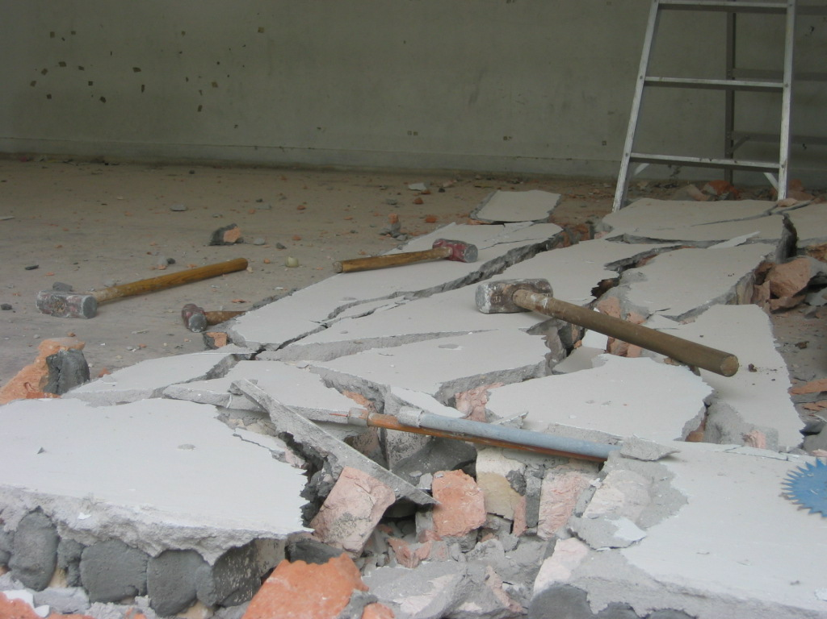

Sledge Hammers
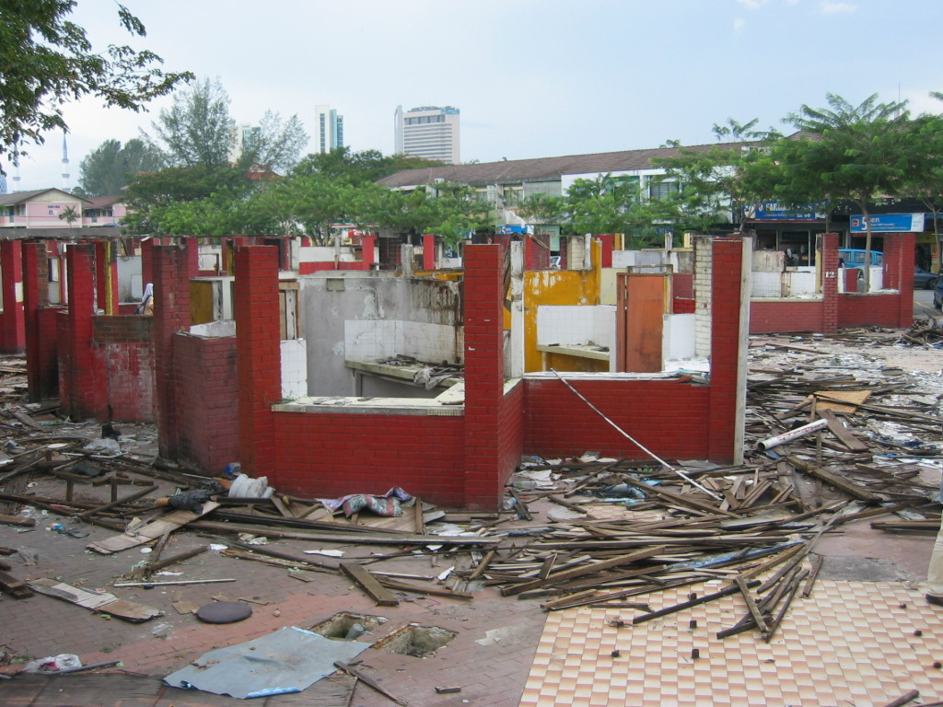

Piecemeal demolition

3.2 By Machine

Simple roof structures supported on wall plates should normally be demolished to the level of wall plates by hand, but if this may involve unsafe working, then demolition totally by machine may be appropriate. Where a building that is to be demolished by machine is attached to another structure, the two properties should be separated by the use of hand methods before the main demolition process begins.

When any part of a building is being demolished by a balling machine, pusher arm or similar equipment, only the machine operator should be allowed close to the working area. The cabs of all machines should be strong enough to protect the operator against the fall of debris. In particular, the windscreen and roof light should be of shatterproof material and guarded by a grille of steel bars or a substantial mesh.

3.2.1 Balling Machine
Balling machines generally comprise a drag-line type crawler chassis fitted with a lattice crane jib. The demolition ball, with a steel anti-spin device, is suspended from the lifting rope and swung by the drag rope. Balling should only carried out by skilled operatives under the control of experienced supervisors using well maintained machines adequate for the proposed duty and standing on a firm, level base.
The manufacturer should be consulted before a machine is used for balling to establish any restrictions on the type or length of jib or the weight of the ball. Balling operations subject cranes to dynamic stresses and wears, and the ball chosen should have the minimum weight necessary for effective use. In many cases, demolition balls of quite lightweight will be adequate.
Floors should be demolished by dropping the ball on the highest remaining floor and allowing the debris to fall inside the building. The debris should be removed regularly to prevent excessive weight accumulating on the lower floors. Walls or columns can be demolished either by swinging the ball in line with the stationary jib, using the drag rope, or by slewing the jib. The ball should not swing by derricking the jib.

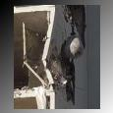

Demolition ball
3.2.2 Hydraulic Pusher Arm
Articulated, hydraulically-powered pusher-arm machines are normally mounted on a tracked or wheeled chassis, and have a toothed plate or hook for applying for applying a horizontal force to a wall. The machine should stand on a firm level base and apply force by a controlled movement of the pusher arm.
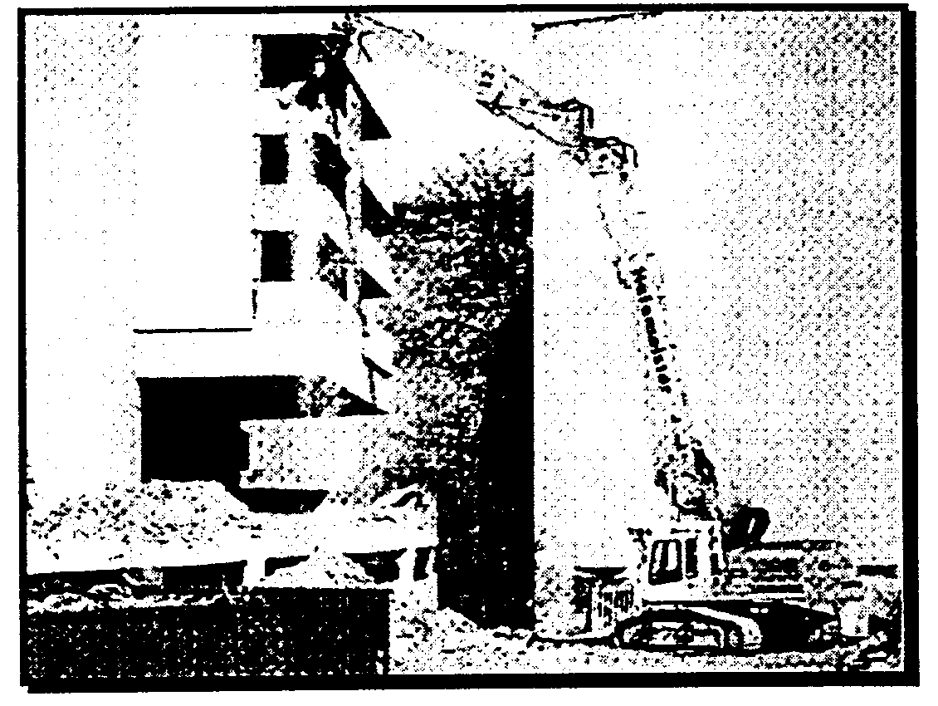

Hydraulic pusher arm

3.2.3 Explosives
If explosives are to be used for demolition, the planning and execution, include pre- weakening, should be under the control of a person competent in these techniques. For large demolition, the competent person is likely to be an experienced explosive engineer; for smaller work, a shot- firer may be sufficient.
When the use of explosives is contemplated, it is usual to employ a technique that will ensure the total demolition of the whole building by staging a controlled collapse. The explosive charges are set and fired in a sequence that will weaken the structure in such a way that the building collapses in upon itself.
Although we tend to think of explosives as devices producing spectacular bomb-like explosions, the use of non- explosive "explosives" is now at an advanced stage. These non- explosive techniques are essentially expanding charges that achieve the same results as explosives but without the noise and initial devastating blast.
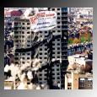

Explosives

    - Pressure Bursting, Mechanical Bursting and Chemical Bursting
Pressure bursting can be used in cases where relatively quiet, dust- free, controlled demolition is preferred.
Both mechanical and chemical pressure bursting split the concrete, either with a splitting machine operating on hydraulic pressure provided by a motor in the case of mechanical bursting, or through the insertion of expansive slurry into a pre-determined pattern of boreholes in the case of chemical.bursting.
The split concrete is then easily removed, either by hand or by crane. Hydraulic and chemical pressure bursting break up concrete structures with a minimum of noise and flying debris. Both methods work by applying lateral forces against the inside of holes drilled into the concrete, and can do virtually any job other demolition methods are capable of. However, rather than shattering the concrete into bits as dynamite and impact tools would, the lateral forces build up over time to crack the concrete into smaller sections.


Bursting Method Effects

Mechanical bursting highlights
- Inexpensive, quiet, no vibration
- Initial drilling of holes for splitter does produce some noise and vibration
- Diamond-tipped coring machine greatly reduces noise and vibration during hole drilling, but is much more expensive
- Controlling crack direction and movement of demolished concrete can be difficult
- Hand-held or machine-mounted breaker may be needed to expose reinforcing bars for cutting
Chemical bursting highlights
- More costly method of pressure bursting
- Can split concrete in a controlled manner
- In excess of 4300 psi of expansive pressure may be generated to produce concrete cracking within 10 to 20 hours
- Quiet, no vibration, little or no dust
- Temperature sensitive: freezing greatly reduces effectiveness
3.2.5 Overturning - Wire Rope Pulling
This method is the application of a horizontal force at a high level by pulling with wire ropes attached to winches or vehicles, and allowing the impact on overturning to demolish the building or structure. An adequate steel cab or cage should protect the winch or the pulling vehicle and the operator. Building over 21m high should not normally be demolished by rope pulling.

3.2.6 Impact Hammer and Nibblers
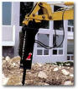

Impact Hammer
Impact hammers normally have a track or wheel mounted chassis, an articulated boom, and a heavy duty pick vibrated by hydraulic or pneumatic power to demolish concrete or masonry. Nibblers use a rotating action to snap brittle materials such as concrete or masonry. In either case, material should be removed from the top of walls or columns in courses not greater than 600mm in depth, steel reinforcement should be cut separately as necessary.
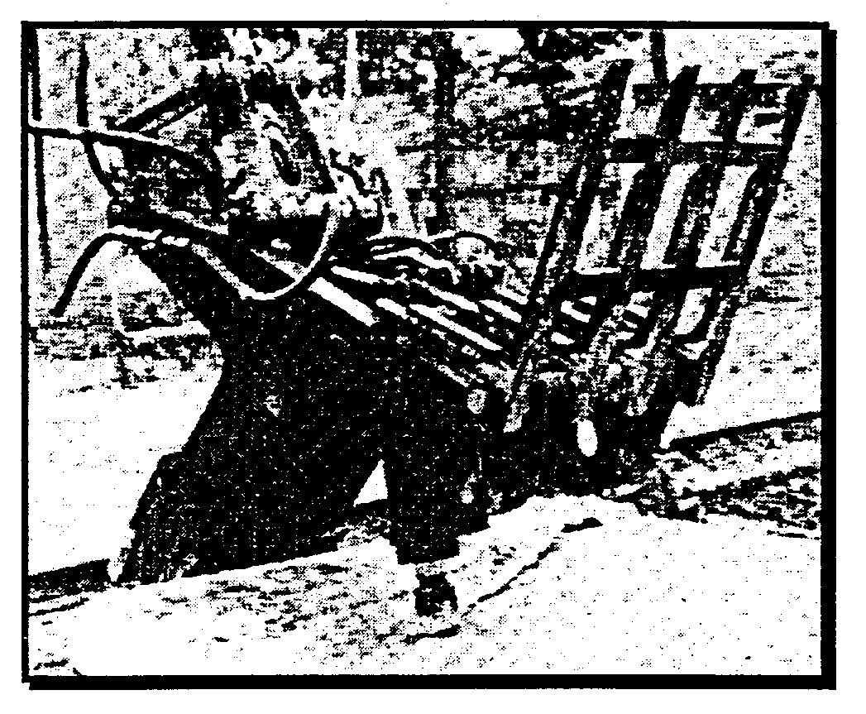
Nibblers

    - Pre-Weakening

Buildings and structures normally have structural elements designed to carry safely the loading likely to be imposed during their life. As a preliminary to a deliberate controlled collapse, after loads such as furnishings, plant and machinery have been removed, the demolition contractor may be able to weaken some structural elements and remove those new redundant.

This pre-weakening is essentially a planned exercise and must be preceded by an analysis of its possible effects on the structure until it collapses, to ensure that the structural integrity of the building is not jeopardized accidentally. Insufficient information and planning relating to the structure may result in dangerous and unsafe work.

    - Deliberate Controlled Collapse

The deliberate collapse of the whole or part of a building or structure requires particularly high standards of planning, supervisions and execution, and careful consideration of its effect on other parts of the structure or on adjacent buildings or structures. A surrounding clear area and exclusion zone are required to protect both personnel and property from the fall of the structure itself and debris which may be thrown up by the impact.

The collapse is usually achieved either by removing key structural elements (e.g. with explosive charges) or by wire rope pulling at a high level to overturn the structure. The possible modes of failure must be studied to ensure that the method selected will produce the required pattern of collapse. If the operation is not successful, the remaining structure may be extremely dangerous for the completion of the demolition. Demolition by deliberate controlled collapse is not usually appropriate for pre-stressed concrete except for simple pre-tensioned floor planks or slabs.

4.O CASE STUDY

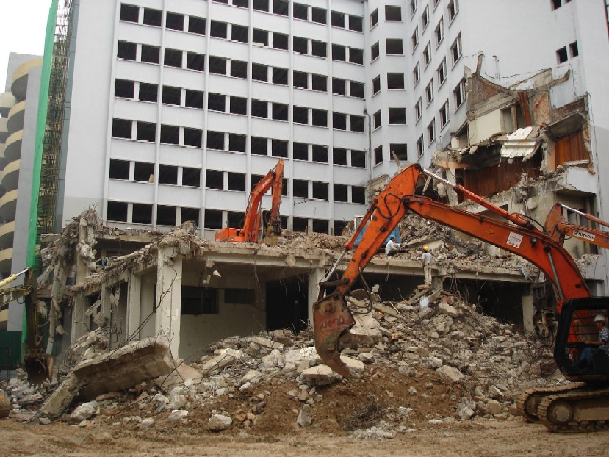

Kompleks Perniagaan dan Pusat Latihan Keusahawanan Mara

This case study will describe the sequence and procedure for the demolition work task which also describe the technical method of application and the sequence of works to be carried out for completion for the project construction of Kompleks Perniagaan dan Pusat Latihan Keusahawanan Mara.

The choice of demolition methods will depend on the nature of the building, structure and its environment. Apart from that, risks to the public, operatives involved in the demolition process and adjacent structures and buildings should also be considered. From our investigation, the demolition works for Kompleks Perniagaan dan Pusat Latihan Keusahawanan Mara use top down demolition, using safety equipments, transportation vehicles, material handling equipments, hand tools and machineries such as excavators, backhoes, bulldozers and cranes.

Demolition Period

Normally, every project has the period to finish the construction. This project is estimated to complete within five (5) months.
Personnel Responsibilities

Project Manager, Site Manager, Site Supervisors and Civil and Structure Consultant are the personnel responsible in the demolition process. All of them have their own responsibilities which had to be properly manage to ensure that the demolition process work smoothly.
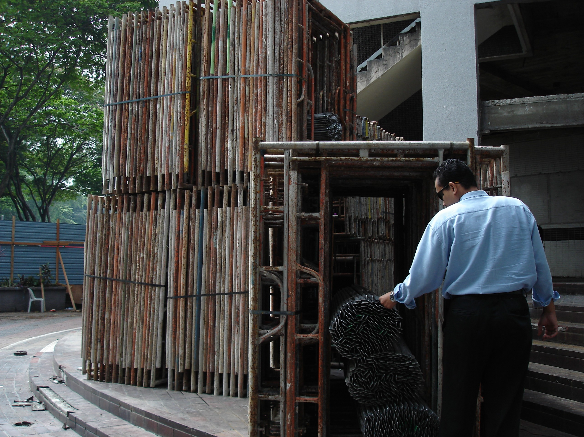

The Site Supervisor check the equipment to ensure it’s in proper manner
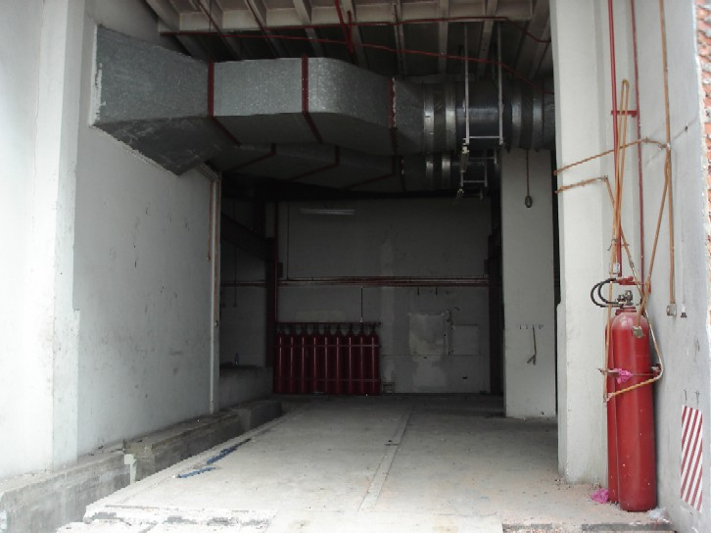

Items which can be salvaged

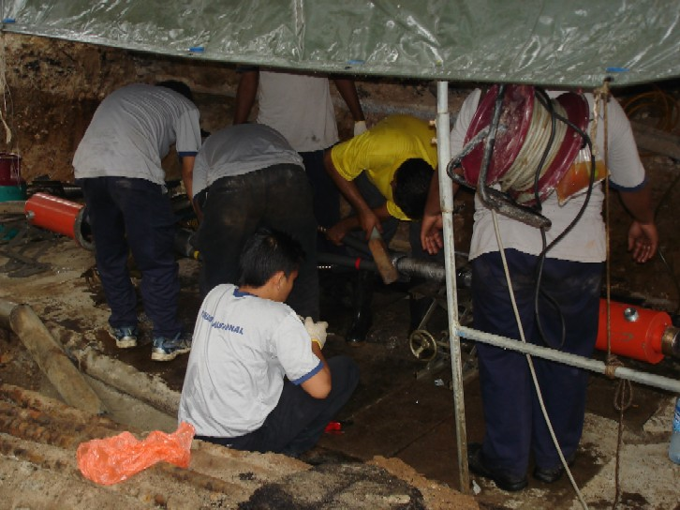

All of the services will be treated at proper manner
to avoid obstructions during demolition process
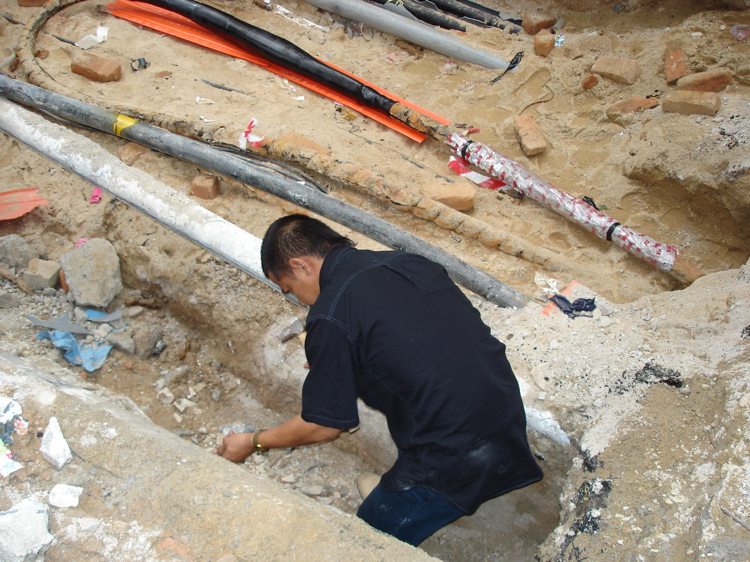

All of underground electric cable and water piping
must be identified and marked for safety
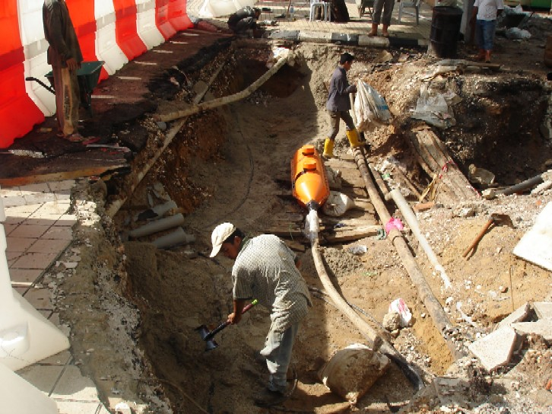

Electric cables and water piping must be secured
to avoid hazardous problems such as electric shock
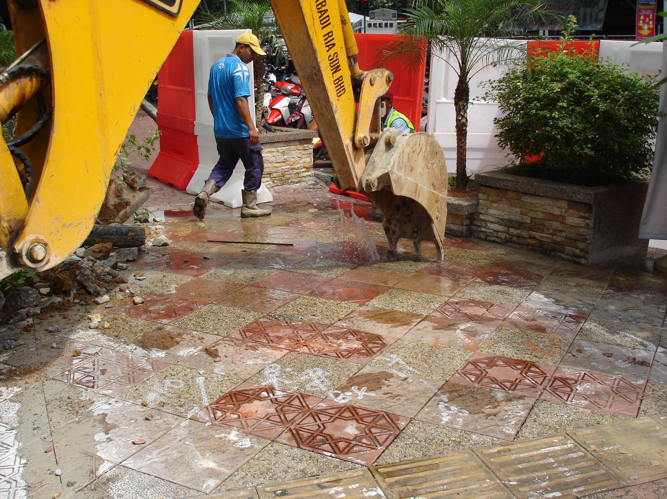

Electric cables and water piping must be identified
to avoid problems such as broke of water piping
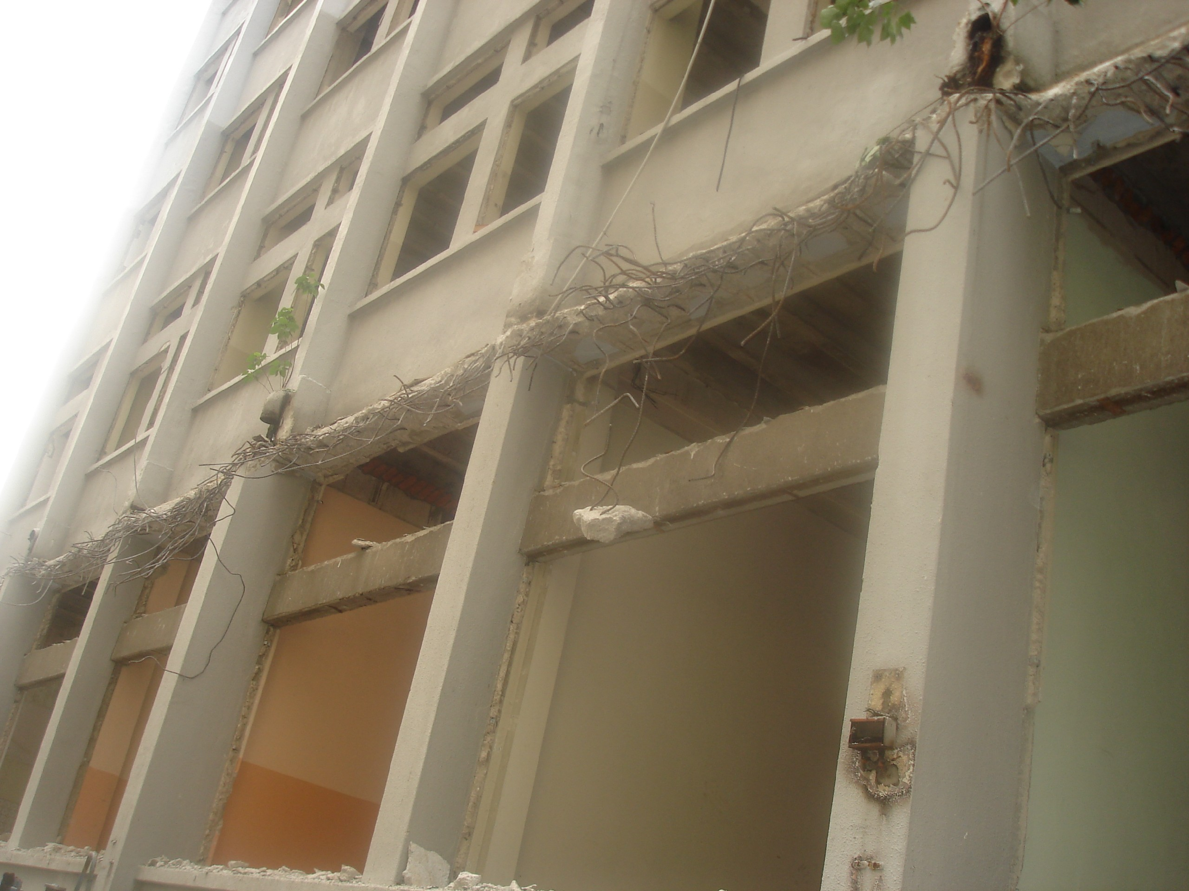

All of structural components of the building must be
secured using shoring if needed

Plants and Equipments

- Hand Tools
- Machineries (Cranes, Backhoe, Excavators and Bulldozer)
- Catch Screen (If Required)
  - A protective structure made of suitable such as scaffold tubes and planking, and fixed to the face of the building or to the perimeter fencing, to contain falling debris during demolition.
- Chute
  - A through of tube used to transfer debris from one level to another, set at an angle to prevent free falling
- Backhoe For Transferring Materials
- Hoarding
- Machine- Lifted Platform
- Gantry
  - A structure covering a public way providing protection from both side and overhead.
- Propping
- Pulling rope
  - A wire rope used in conjunction with an anchored winch or attached to a tracked or heavy vehicle, to pull down a selected part of the building.
- Pusher Arm
  - A steel attachment fixed to an extended boom on mechanically operated mobile equipment.
- Scaffolding
- Toe Board
  - A board placed on edge round a working platform, to prevent tools or materials from falling

Proposed List of Equipments

Mobilization of equipments will take 7 (working) day upon receiving the letter of award. The proposed List of the equipment is as the following:-

  - Concrete Breaker (Ex-100) - 2
  - Excavator (Ex-100) - 2
  - Mobile Crane (120 tones) - 2
  - PC 300 Hydraulic Excavator - 2
  - MS 300 Long Arm Hydraulic Excavator - 1
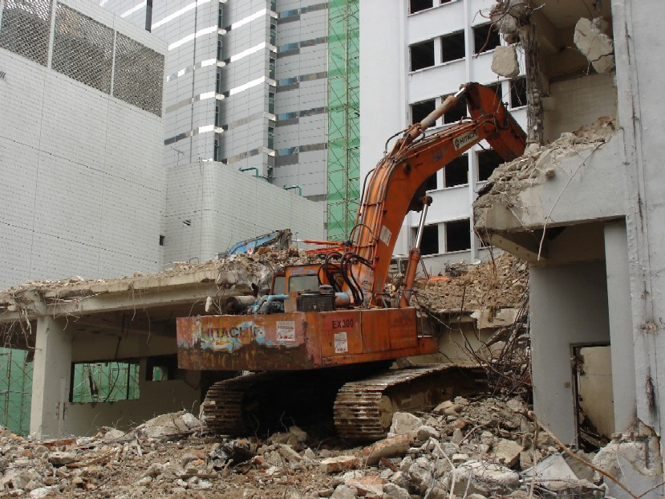

Excavator

Demolition Method

Generally and in principle, demolition works normally take about 5 months, and beginning from top- most floor and gradually moving down right to the ground floor. Three structures would be demolished including chillers plinth, prayer room, and engine room using four units of machinery namely, :-

  - concrete breaker
  - excavator
  - crane

To commence operation, these 4 types of machineries would be brought up using 120 tons mobile crane. The first two concrete breakers would be located on both the right and left of building, followed by the excavator to be positioned in the middle section of the building. Scaffolding would be erected p to 7 1/2 floor of the building while safely net would be installed outside the scaffolding. Rubbish dumping space would be positioned using both lifts core and stairways.
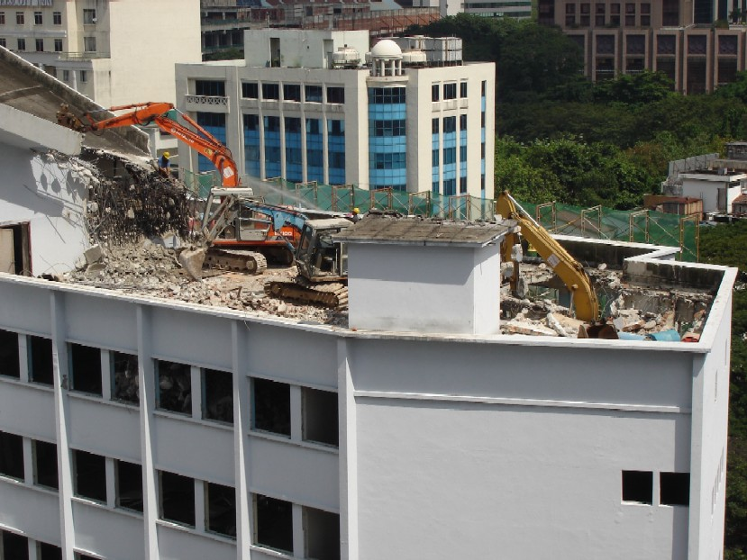

Machineries been brought to the top most floor
for demolition process start from there and
gradually moving down right to the ground floor

Demolition would be done accordingly to zone for this project like example zone A and zone B. In zone A, chillers plinth would be demolished and parts of the debris would be used as platform on which the concrete breakers would be positioned. This is done to reduce vibration of the floor while minimizing the risks of collapse. The remaining debris would be removed by dumping through the lift core and stairways.

To prevent dust from hovering around, water would be sprayed regularly in the affected areas. Water would be source from water tanks where is located at the base of the building using booster pumps. Similarly, demolition works at Zone B, that would be prayer room and part of the debris would be used as a platform on which the concrete breaker would be positioned while the remaining debris would be removed through the lift core and the nearest stairways.
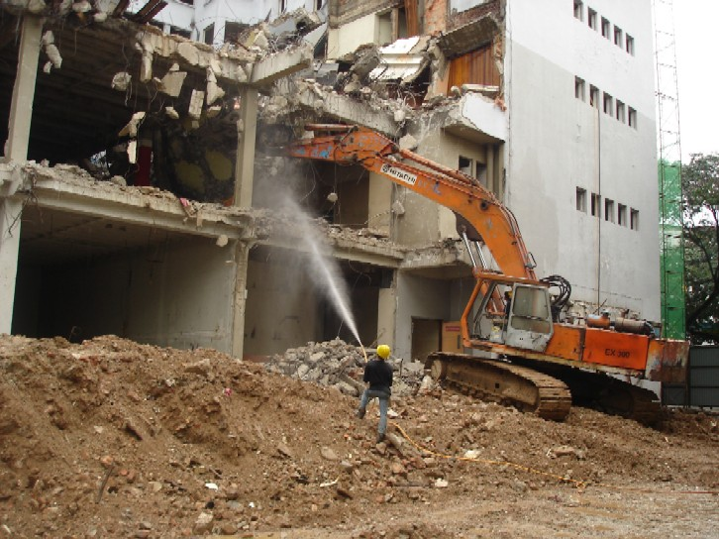

Water been sprayed to prevent dust from hovering around

After completing the demolition works at the top- most floor, a hole would be made at strategically selected location to enable the machinery to be moved down to the floor below to continue working on the demolition works. At the eight floors, the concrete breakers, which are positioned at the stairways, would be knocking down the remaining floor above.

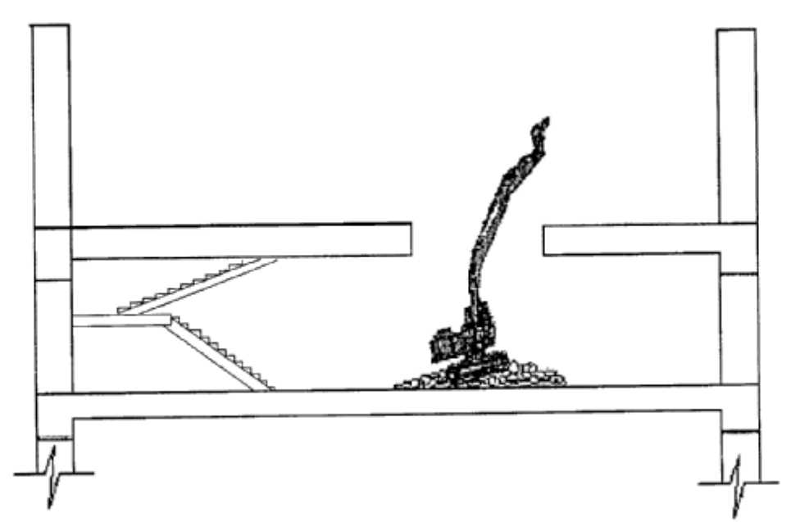

Accordingly, scaffoldings would be removed gradually floor- by- floor together with safety net. For instance, when the demolition works reach 6th floor (subject to the availability of storage where the debris is dumped off), all the three machineries would then be removed out of the building. The demolition work would continue from the ground level using MS 300 Long Arm Hydraulic Excavator besides two units of Komatsu PC300 Hydraulic Excavator. Debris from the demolition works at 6th floor downward would then de removed using dump trucks from four specified collecting point. As Built Drawing would then be submitted right after debris removal is completed.
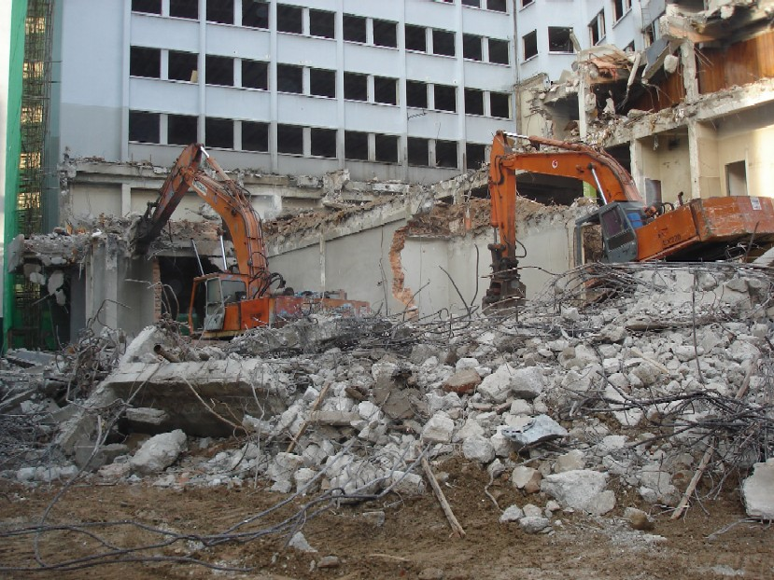

Final demolition to the ground floor
CONCLUSION

The choice of method depends to type of structure, site condition, location of site and type of constructions. The different method of demolition will determine the plant and tools equipment. Also, the types of structure to be demolished for example a frame skeleton structure will be different form a steel structure. The plant and equipment of demolition also affects the size of building and location of site. In most cases, large building always use large plant such as trailer mounted hydraulic and etc.

Besides that, there is various method of demolition commonly used nowadays and new methods are beginning to be examined and use. The method such as hand demolition is very conventional. However, demolition ball, pusher arm, deliberate collapse, pulling by wire ropes, explosives, demolition by expansion, bursting, hydro laser, radar, diamond saws and drills, the slag eater and cryogenic method are quite new to the industry and not yet fully used by our local contractors. Maybe it is due to the fact the conventional method is cheap, very minimum labor oriented and requires common equipment. In reality, demolition of buildings in Malaysia is not so preferred. If there is any, it is in small quantities for house renovations.

Last but not least, demolition involves dangerous operation in the construction site. Therefore before commencing demolition of the various sections of works, steps by steps should be ensure by contractor including safety properties factors and also providing all necessary supporting to ensure the safety of the third party.

REFERENCES

    - Roy Holmes, Introduction to Civil Engineering Construction – Third Edition, the College of the Estate Management, London, 1995.
    - Y. Kasai (Edited), Demolition Methods and Practice Volume One, Chapman and Hall Ltd, Great Britain, 1988.
    - Section D - Demolition Works, Malaysian Standard Method of Measurement of Building Works Second Edition, SMM2.
    - Internet Websites:
4.1) www.dexpan.com
4.2) www.sti.com
    - R. Chudley, Construction Technology - Third Edition (Revised), Longman Publishers, London, 1999.
    - Decommissioning and Demolition, Proceedings of the Second International Conference 1990, University of Manchester.
    - BS 6187: 1982 Code of Practice for Demolition.

APPENDIX

